How To Build SymPort

Required tools and settings:
- Raptor
- Epoc32 for Symbian OS 9.5
  - Set EPOCROOT
  - Add $EPOCROOT/epoc32/tools and $EPOCROOT/epoc32/gcc/bin to your $PATH environment variable

- Get Raptor (in the following example from perforce)
  - I assume you sync raptor to D:\raptor
  - Perforce Sync //DP/master/build/raptor/…
  - SET SBS_HOME=D:\raptor
  - SET PATH=%SBS_HOME%\bin;%PATH%
  - Now you should be able to check raptor version invoking: sbs -v
- Get SymPort
  - Perforce Sync //DP/master/sf/dev/hostenv/cpptoolsplat/symport/...
- Get Epoc32 for Symbian 9.5 (in the following example with CBR tools)
  - Set your EPOCROOT and set repositories for OS 9.5 (in reltools.ini)
  - latestver gt_techview_baseline (this returns build version e.g. 95_274_Symbian_OS_v9.5)
  - getenv gt_techview_baseline VERSION_RETURNED_FROM_LATESTVER (e.g. 95_274_Symbian_OS_v9.5)
- Build SymPort
  - Run sbs -b bld.inf -c tools2 in symport group directory

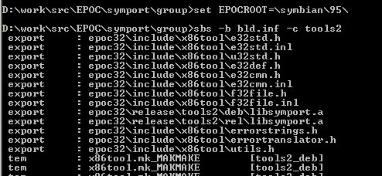

For more information about SymPort read //DP/master/sf/dev/hostenv/cpptoolsplat/symport/group/how to use symport.doc.

